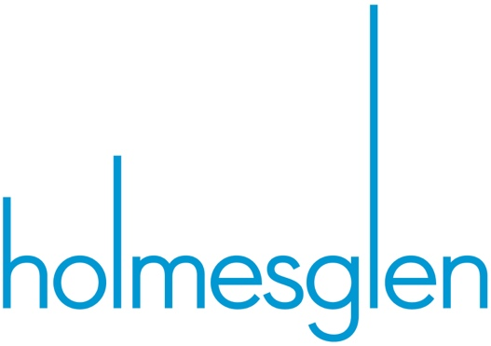


ICTSAS432 Identify and resolve client ICT problems

ICTICT426 Identify and evaluate emerging technologies and practices
BSBCRT404 Apply advanced critical thinking to work processes

Learner version

Emerging ICT Tech Assessment 2
Portfolio

Disclaimer: This resource was developed by Holmesglen Institute of TAFE in 2024 for the State of Victoria (Department of Education and Training) for educational purposes, is © State of Victoria (Department of Education and Training) and is available under a Creative Commons Attribution Non-commercial 4.0 International (CC BY-NC 4.0) license.
The license does not apply to: Trademarks or branding, including the Victorian Government logo and any unattributed content supplied by third parties




Learner version

Emerging ICT Tech Assessment 2
Portfolio

Learner information
Learner name: Van Minh Le | Learner ID: 100693330

Section A – Program/course details
Qualification code: ICT40120 | Qualification title:  Certificate IV in Information Technology (Web Development)  Certificate IV in Information Technology (Programming)
Unit code:  Emerging ICT Tech  ICTSAS432  ICTICT426  BSBCRT404 | Unit title:  Identify and resolve client ICT problems  Identify and evaluate emerging technologies and practices  Apply advanced critical thinking to work processes
Pre/co-requisites: N/A

Section B – Assessment task details
Assessment number: 2 of 2 | Semester/year: 1/2025 |  | Due date: Session 15
Duration of assessment: 4 sessions |  | Assessment task results: This assessment task will be marked as:  ☒ Ungraded result: satisfactory or not yet satisfactory

Section C – Instructions to learners

Assessment task description:
Portfolio
This assessment is comprised of the following parts:
• Part A - Prepare To Resolve Client ICT Problems
• Part B - Initial Planning
• Part C – Initial Feedback
• Part D – Create Maintenance Report
• Part E - Confirmation & Feedback
• Part F - Final Maintenance Report
Project Brief

Introduction
Motionweb Studios is a web agency that has been running their web-design business for several years. However, they are facing many difficulties regarding the efficiency of its design systems when working with clients and outdated portfolio showcase designs. They require critical thinking to upgrade their existing showcase designs and design systems.

Your task is to provide maintenance with the intention to addressing the issues logged into the client's issue tracking database found on Brightspace. The assessor will be representing the Lead Web Developer throughout this project. Each question must be completed as per the instructions. You will then seek feedback from your mentor (teacher) to then create a maintenance report that meets the following requirements.

Problem
In order to be successful in providing maintenance, you are required to design and develop showcase web designs for any ONE of the following products/areas of interest:
- Band
- Car company
- Mobile phone company
- Furniture retailer
- Clothing retailer
- Astronomy Information website
- Anime website
- Your own idea - please see your teacher to obtain permission.

Based on the choice you have made there are some business requirements that you need to be aware of including:

Project outcomes:
  - Landing (Index) page
  - 3 other pages (or sections) of your choice (minimum)
  - Original logo design

Project requirements (objectives)
- Technical Specifications
  - Colour mode: RGB
  - Screen resolution: 72ppi
  - Screen size Dimensions: Minimum wrapper size 960px.
  - Platform: Mobile or a desktop design.
  - Note: you may design full screen or a wrapper sitting in the middle of a page
- Design Specifications
  - It must be a 2 columns website (most pages but not all, you may have more columns)
  - It must have a form and a table.
  - You must have 4 separate pages, or 4 sections, or a combination of pages and sections.
- Style, colours and content
  - The overall colour scheme and style is up to your own discretion. .
  - You must record your copyright clearance for all images, fonts and assets.
  - You must create or source your content, assets and text.
- Visual Communication Principles
  - You must consider and apply usability principles in your design (Use the 25 point checklist, or something to assist you, found on Brightspace)
  - Ensure correct flow of information architecture.
  - You must evaluate your design and receive feedback on them.
- Computer program
  - Figma
  - Photoshop
  - Illustrator
- Final File Formats
  - Your native files .psd and or .ai, or if using Figma, fig.
  - Export a .jpg .png or.pdf of each page of your design

Section D – Conditions for assessment

Unit application:
- This is an individual task.
- You must meet all criteria listed in the marking guide to be satisfactory in this task.
- You must submit all required working files, documentation, and any other assets that may be required in a zipped file, including the completed and signed coversheet, where necessary. The assessment must be completed and submitted electronically to Brightspace by the due date. If this is not possible, you must contact your assessor to gain written approval for an alternative arrangement for submitting the assessment.
- If not successful within the enrolment period as per Holmesglen assessment procedure, you will be requested to resubmit within 7 days of receiving feedback. You will have the opportunity to resubmit if any part of the assessment is deemed unsatisfactory (you are permitted TWO (2) resubmission per assessment task). Resubmissions must be submitted by the resubmission due date provided by your teacher.
- This task is open book. You may use the internet for research purposes only. All answers must be in your own words. Where a quote is used, you must cite the information source.
- If you feel you require special allowance or adjustment to this task, please discuss with your assessor within one week of commencing this assessment. Any change to assessment arrangements must be reviewed by the Education Manager and approved by the Head of Department.
- You can appeal an assessment decision according to the Holmesglen Assessment Complaints and Appeals Procedure.
- You are expected to dedicate time to develop this assessment task both in and out of the classroom.
- Leaner must contribute to and abide by organisational standards including intellectual property, privacy laws, and plagiarism and academic honesty. Further information is detailed at: https://holmesglen.edu.au/Students/Student-Resources/

Equipment/resources learners must supply: | Equipment/resources to be provided by the RTO:
Learners opting to BYOD laptop or intending to learn remotely will require access to:  Holmesglen Computer Classroom:  data projector, whiteboard, computer with double screens, mobile Cisco Spark Board, Conference camera  HP Z1 Entry Tower G5  • Dual Displays 24” HP Monitor  • CPU: Intel Core i7-9700K @ 4GHz  • Motherboard: 8591  • RAM 32GB  • 1TB SSD  • OS: Windows 10  This will vary as CAIT upgrades computer rooms.  • Internet connection  Applications available at ZENworks and Holmesglen MyHorizon and also free to download via url below:  • Brightspace (Learning Management System) access - https://holmesglen.brightspace.com/  • 365 Microsoft office suite also can be downloaded via https://portal.office.com - free to Holmesglen students  • LinkedIn Learning – https://www.linkedin.com/learning/  • WebEx - https://holmesglen.webex.com/  • 7Zip or an equivalent compression utility - https://www.7-zip.org/download.html  • Google Chrome – recommended web browser  • OneDrive - https://www.microsoft.com/en-ww/microsoft-365/onedrive/online-cloud-storage - free to download  • The relevant legislation/regulation and using policies, procedures, processes available in Brightspace course offering - Resources | This is a blended learning course and as such a remote learner will access their own computer equipment as per the specification provided. The Institute will provide the following:  Learners opting to BYOD laptop or intending to learn remotely will require access to:  A MAC or PC/laptop with the following minimum specification:  Quad Core CPU  • CPU with minimum 4GHz processor or faster  • RAM 16GB  • 200GB of storage  • Windows 10 OS, or virtual machine installed with Windows 10 OS (available free from https://developer.microsoft.com/en-us/windows/downloads/virtual-machines/ or https://www.microsoft.com/en-us/evalcenter/evaluate-windows-10-enterprise)  • Monitor 24" (PC only, dual monitor optional but preferred)  • Headset with microphone (webcam optional but preferred)  • Access to reliable internet connection (ADSL or cable connection desirable)  Applications are available at Holmesglen MyHorizon and also free to download via url below:  • Brightspace (Learning Management System) access - https://holmesglen.brightspace.com/  • MyHorizon - https://myHorizon.holmesglen.edu.au - free to download  • 365 Microsoft office suite also can be downloaded via https://portal.office.com - free for all Holmesglen students  • LinkedIn Learning – https://www.linkedin.com/learning/  • WebEx - https://holmesglen.webex.com/  • 7Zip or an equivalent compression utility - https://www.7-zip.org/download.html  • Google Chrome – recommended web browser https://www.google.com/  • OneDrive - https://www.microsoft.com/en-ww/microsoft-365/onedrive/online-cloud-storage - free to download  - • The relevant legislation/regulation and using policies, procedures, processes available in Brightspace course offering - Resource

Section E – Assessment questions/criteria
Assessment number: 2 |  | Assessment title: Portfolio
Unit code:  Emerging ICT Tech  ICTSAS432  ICTICT426  BSBCRT404 | Unit title:  Identify and resolve client ICT problems  Identify and evaluate emerging technologies and practices  Apply advanced critical thinking to work processes

Project Brief

Introduction
Motionweb Studios is a web agency that has been running their web-design business for several years. However, they are facing many difficulties regarding the efficiency of its design systems when working with clients and outdated portfolio showcase designs. They require critical thinking to upgrade their existing showcase designs and design systems.

Your task is to provide maintenance with the intention to addressing the issues logged into the client's issue tracking database found on Brightspace. The assessor will be representing the Lead Web Developer throughout this project. Each question must be completed as per the instructions. You will then seek feedback from your mentor (teacher) to then create a maintenance report that meets the following requirements.

Problem
In order to be successful in providing maintenance, you are required to design and develop showcase web designs for any ONE of the following products/areas of interest:
- Band
- Car company
- Mobile phone company
- Furniture retailer
- Clothing retailer
- Astronomy Information website
- Anime website
- Your own idea - please see your teacher to obtain permission.

Based on the choice you have made there are some business requirements that you need to be aware of including:

Project outcomes:
  - Landing (Index) page
  - 3 other pages (or sections) of your choice (minimum)
  - Original logo design

Project requirements (objectives)
- Technical Specifications
  - Colour mode: RGB
  - Screen resolution: 72ppi
  - Screen size Dimensions: Minimum wrapper size 960px.
  - Platform: Mobile or a desktop design.
  - Note: you may design full screen or a wrapper sitting in the middle of a page
- Design Specifications
  - It must be a 2 columns website (most pages but not all, you may have more columns)
  - It must have a form and a table.
  - You must have 4 separate pages, or 4 sections, or a combination of pages and sections.
- Style, colours and content
  - The overall colour scheme and style is up to your own discretion. .
  - You must record your copyright clearance for all images, fonts and assets.
  - You must create or source your content, assets and text.
- Visual Communication Principles
  - You must consider and apply usability principles in your design (Use the 25 point checklist, or something to assist you, found on Brightspace)
  - Ensure correct flow of information architecture.
  - You must evaluate your design and receive feedback on them.
- Computer program
  - Figma
  - Photoshop
  - Illustrator
- Final File Formats
  - Your native files .psd and or .ai, or if using Figma, fig.
  - Export a .jpg .png or.pdf of each page of your design

Criteria for assessment |  |  | Satisfactory |  | Comment
 |  |  | Yes | No
The following has been submitted for assessment:
Supplementary documentation – filled out, signed and dated |  |  | ☐ | ☐
Working files of designs (.fig .pdf .psd .ai) |  |  | ☐ | ☐
Final maintenance report document (.pdf or .docx) |  |  | ☐ | ☐
Questions to be answered by the learner.
Provide your responses in the boxes below each question.
Part A | Prepare To Resolve Client ICT Problems
Question 1: |  | What were the problems that the client is specifically having and how is it impacting the client’s design procedures? (See Project Brief) |  |  |  | Satisfactory response
 |  |  |  |  |  | Yes ☐ | No ☐
Answer:  - Client problems:  - The inefficiency of design systems may make harder to work quickly, produce quality work. It could frustrate when working with clients.  - Outdated Portfolio showcase designs may not align with modern design trends and fails to impress potential clients.  - Impact on the client’s design procedures:  - The inefficiency of design systems reduces client satisfaction. It slows down project delivery.  - An outdated portfolio creates a weak brand image.  - Portfolio showcase designs falls behind modern standards can lower the business's competitiveness and hinder growth. |  |  |  |  |  | Comment:
Question 2: |  | What was the client’s response regarding the design problem stated? (See Project Brief) |  |  |  | Satisfactory response
 |  |  |  |  |  | Yes ☐ | No ☐
Answer:  - The client has recognized of the problem.  - They require critical thinking to upgrade their existing systems and improve the showcase designs. |  |  |  |  |  | Comment:
Question 3: |  | In the database that the client uses, what are the logged requests that have been made, and what are the requirements for the task? (See Brightspace) |  |  |  | Satisfactory response
 |  |  |  |  |  | Yes ☐ | No ☐
Answer:  - The designs are too old and need to be updated.  - Collaboration between designers is difficult with offline tools.  - Photoshop and Illustrator have difficulty keeping consistency with styling.  - Giving clients feedback is difficult with .jpg and .pdf files.  - There is no way to animate the website using current Adobe Photoshop and Illustrator technology. |  |  |  |  |  | Comment:
Question 4: |  | What are the different resolution options that can be used to solve the design workflow problem of the client? |  |  |  | Satisfactory response
 |  |  |  |  |  | Yes ☐ | No ☐
Answer:  - We can use Figma tool to allow real-time teamwork and improve communication between designers.  - We will update and modernize the portfolio designs to replace the outdated ones.  - We standardize design systems to keep consistency in styling across all projects.  - We use interactive prototypes instead of static .jpg and .pdf files for easier client feedback.  - We will use design tools that support website animation, like Figma instead of just Photoshop and Illustrator. |  |  |  |  |  | Comment:
Question 5: |  | What are the constraints that are in place for the task and how will this affect the resolution option? |  |  |  | Satisfactory response
 |  |  |  |  |  | Yes ☐ | No ☐
Answer:  - The outcomes of the project must include 4 separate pages, or 4 sections or a combination of pages and sections. It includes the Index page, three other pages and an original logo design.  - The design must comply with specific technical specifications, including RGB colour mode and 72ppi resolution. Additionally, the minimum wrapper size must be 960px, and the design must be suitable for either mobile or desktop platforms.  - The design specifications require the website must have a two or more-column layout on most pages but not all and it must have a form and a table.  - All content of the project must have copyright clearance for images, font and assets.  - The design must comply with visual communication principles.  - The project must use only Figma, Photoshop, or Illustrator for design.  - The final design file formats must be “.fig” when using Figma tool. |  |  |  |  |  | Comment:
Question 6: |  | List the features and functions, attributes, and potential of at least 3 emerging technologies to determine the advantage and disadvantages related to the client’s current design system issues. |  |  |  | Satisfactory response
 |  |  |  |  |  | Yes ☐ | No ☐
Answer:  - Figma:  - Advantage: Solves the collaboration and consistency issues while enabling real-time feedback.  - Disadvantage: Requires transitioning from offline tools and a stable internet connection.  - Adobe XD:  - Advantage: Provides animation capabilities and real-time collaboration, making it easier to deliver interactive prototypes.  - Disadvantage: Some features overlap with other tools and may require additional development for final implementation.  - Webflow:  - Advantage: Allows for no-code design and web development, speeding up the process and enabling advanced animations directly in the design.  - Disadvantage: More complex designs may still require coding, and the platform can be expensive for smaller teams. |  |  |  |  |  | Comment:
Question 7: |  | List the features and functions of at least 3 design workflows related to the client’s current design system issues. |  |  |  | Satisfactory response
 |  |  |  |  |  | Yes ☐ | No ☐
Answer:  - Wireframing and Prototyping Workflow:  - Features: It creates wireframes and prototypes for outline the design, continuous feedback and using tools like Figma to design the project.  - Functions: It improves efficiency, reduce miscommunication, and incorporate client feedback.  - Asset Management Workflow:  - Features: Centralized asset storage, version control, and cross-tool compatibility.  - Functions: It explains workflow improving efficiency, keeps assets up to date and maintains consistency across designs.  - Usability Testing Workflow:  - Features: Application of usability principles, real user testing, and integration of findings.  - Functions: Highlights how usability testing optimizes user experience, ensures logical information flow, and enhances satisfaction. |  |  |  |  |  | Comment:
Question 8: |  | List the sources for finding the features and functions of those emerging technologies. |  |  |  | Satisfactory response
 |  |  |  |  |  | Yes ☐ | No ☐
Answer:  - Official Websites and Documentation.  The primary source provides the most accurate and updated features and functions such as Figma.com, Adobe.com, Atlassian.com for Jira  - Technology Blogs and Reviews.  It offers insights, comparisons, and real-world examples of how the technologies are used. Example: TechCrunch, Smashing Magazine, UX Design.cc  - Online Learning Platforms.  It explains features and functions through structured courses and tutorials. (Coursera, Udemy, LinkedIn Learning)  - Product Tutorials and Webinars  It shows demonstrations of features and how functions are applied in real projects. Example: Figma webinars, Adobe XD tutorials.  - Community Forums and Discussion Groups  Users share experiences, tips, and deeper understanding of tools' capabilities. (Reddit, Stack Overflow, UX communities) |  |  |  |  |  | Comment:
Question 9: |  | What are the differences in workflow between the older design systems the client had versus the workflow in the new design systems? |  |  |  | Satisfactory response
 |  |  |  |  |  | Yes ☐ | No ☐
Answer:  Differences in Workflow: Old vs. New Design Systems  Number Aspect Old Design Systems New Design Systems  1 Tools Photoshop, Illustrator (offline tools). Figma or Adobe XD (cloud-based, collaborative).  2 Collaboration Difficult, files are shared manually. Real-time collaboration and editing.  3 Consistency Hard to maintain styles across files. Design systems and components ensure consistency.  4 Client Feedback Feedback through .jpg or .pdf files. Interactive prototypes and comments directly in Figma.  5 Animation/Interactivity Limited or none. Built-in prototyping and basic animations.  6 Version Control Manual file management. Auto-saving versions in cloud platforms. |  |  |  |  |  | Comment:
Question 10: |  | What are the impacts of the new design systems and workflows on the current client’s web design workflows and practices? |  |  |  | Satisfactory response
 |  |  |  |  |  | Yes ☐ | No ☐
Answer:  - It uses cloud platform tools to improve real-time collaboration, enhancing communication between clients and designers.  - Based on iterative feedback and prototyping tools, the design process is speeding. It allows for rapid adjustments based on client responses.  - A shared design system with reusable components ensures consistent branding and design across all pages, minimizing errors and inconsistencies.  - Prototypes and real-time comments allow clients to provide immediate feedback, reducing delays and improving the design accurately.  - Using automatic version control and asset management reduces time spent on manual tasks, allowing designers to focus on creative work.  - Usability testing and continuous integration of feedback lead to more user-friendly and polished designs. |  |  |  |  |  | Comment:
Part B | Initial Planning
Question 1: |  | What are the changes required to the client’s current design systems and workflow based on the strategies listed? |  |  |  | Satisfactory response
 |  |  |  |  |  | Yes ☐ | No ☐
Answer:  - The client needs to change from offline tools like Photoshop and Illustrator to an Figma for better teamwork and real time collaboration.  - Their current design system must be updated to. It includes consistent styles, reusable components and support for animations.  - They also need to move from static files (.jpg and .pdf) to interactive prototypes for easier client feedback.  - These changes will improve efficiency, consistency, and communication in their design workflow. |  |  |  |  |  | Comment:
Question 2: |  | Develop initial planning and strategy materials to prepare the organization for the impacts of new design emerging technology and provide links or images below. This is to be in the following forms:  - Mood boards  - User Flow Charts  - Logo Designs  - Wireframes |  |  |  | Satisfactory response
 |  |  |  |  |  | Yes ☐ | No ☐

Answer:  Mood Board:  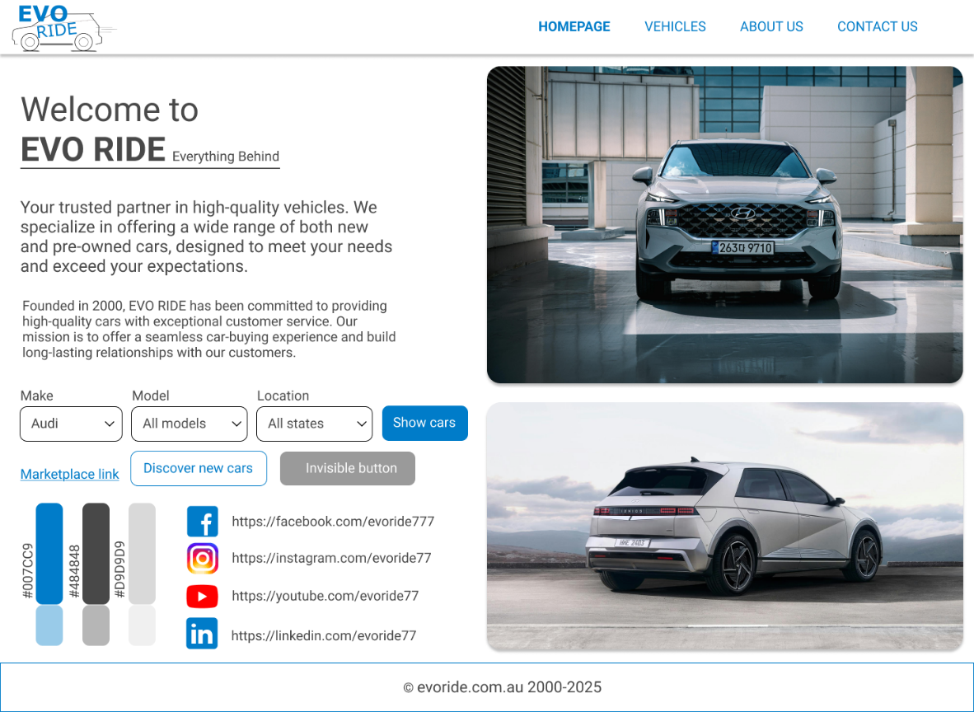  URL: https://www.figma.com/design/TqG4vt9RHHg5zwC6tXwraD/Assessment-2---Identify-and-Resolve-Client-ICT-Problems?m=auto&t=LrhUNoEvIK8fCOzD-6  Sitemap:  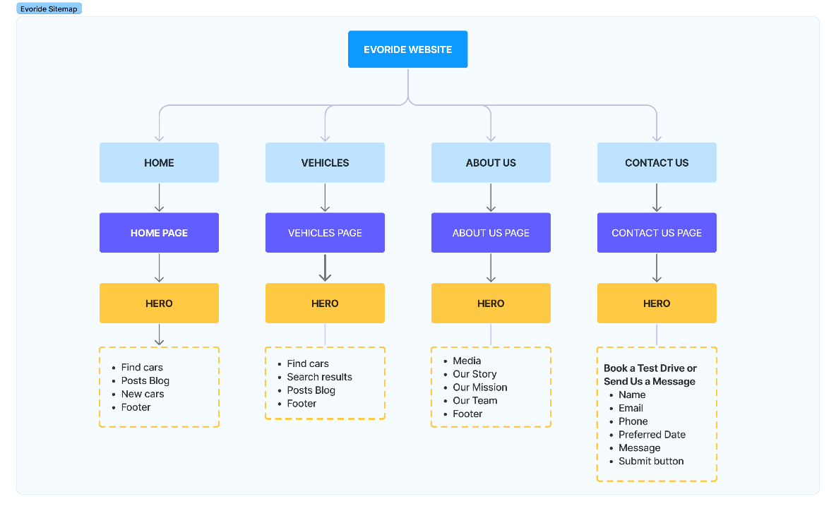  URL: https://www.figma.com/board/iktz28wkJkCqJzg89i5eFF/Evoride-Sitemap?t=LrhUNoEvIK8fCOzD-6  WireFrame  URL: https://www.figma.com/design/TqG4vt9RHHg5zwC6tXwraD/Assessment-2---Identify-and-Resolve-Client-ICT-Problems?m=auto&t=LrhUNoEvIK8fCOzD-6  Homepage  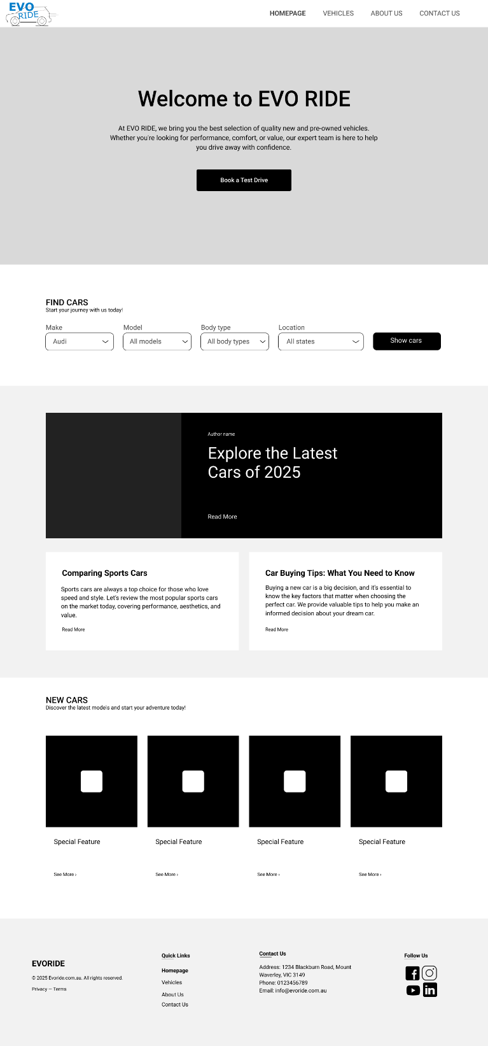  Vehicles page:  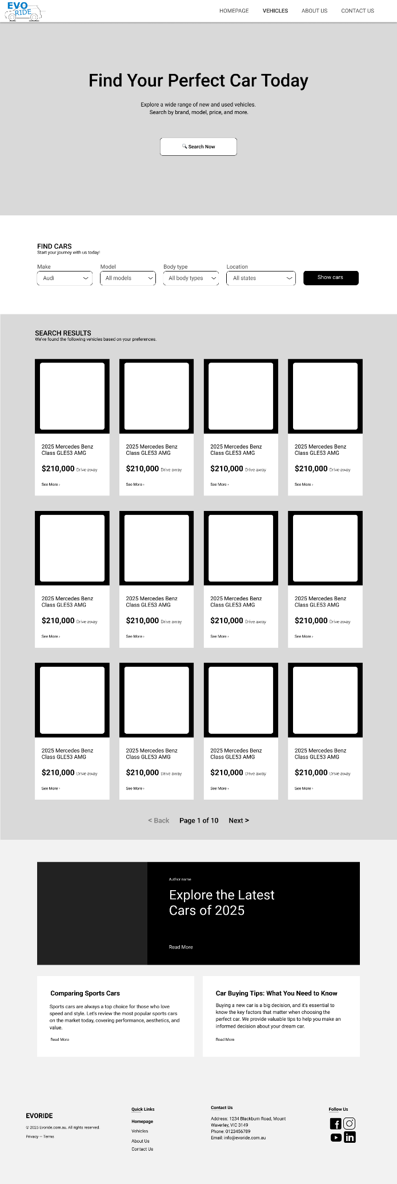  About Us page  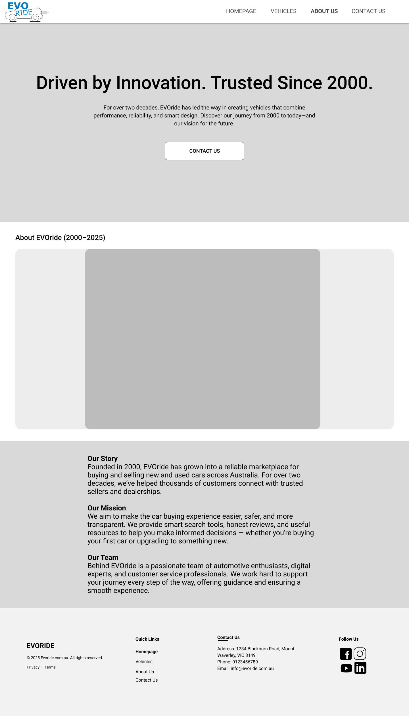  Contact Us Page:  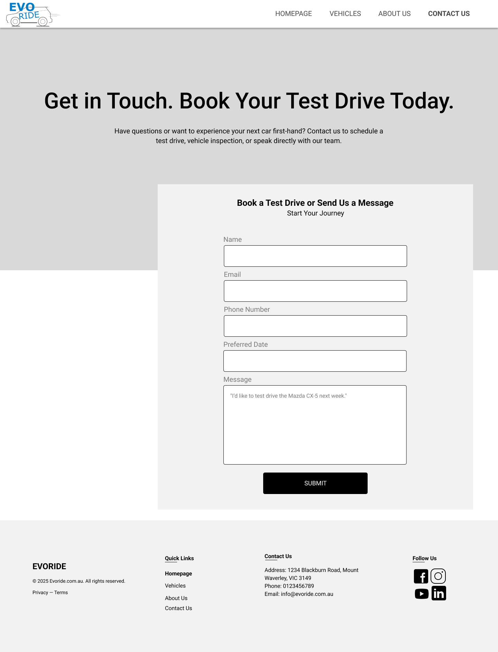  URL: https://www.figma.com/design/TqG4vt9RHHg5zwC6tXwraD/Assessment-2---Identify-and-Resolve-Client-ICT-Problems?m=auto&t=LrhUNoEvIK8fCOzD-6  LOGO: Please find the logo file attached.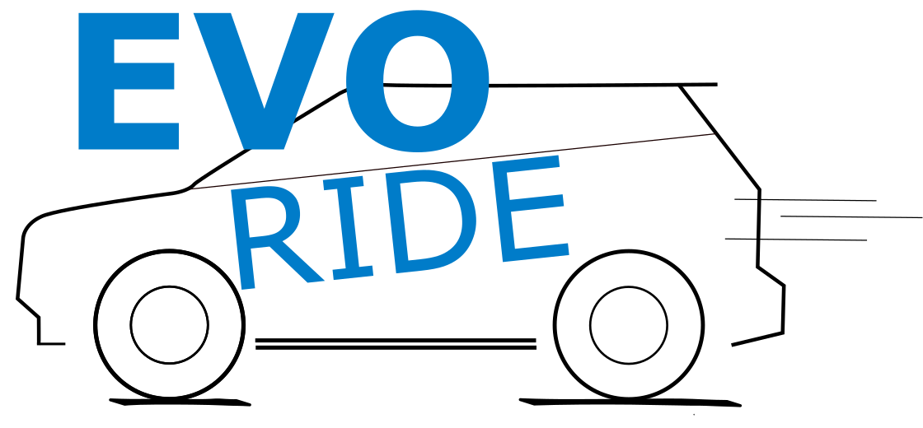  File created by Inkscape. |  | Comment:
Question 3: | In the structure of the organization, what is the framework needed to decide on what needs to be done in accordance with the client’s organizational hierarchy? | Satisfactory response
 |  | Yes ☐ | No ☐
Answer:  - Framework to Align with Client’s Organizational Hierarchy use a RACI Matrix. It includes Responsible, Accountable, Consulted and Informed.  - It based on Motionweb Studios which a small-to-medium-sized agency.  - The CEO or Chief Technology Officer is accountable for final approval.  - The Web Developer Leader is responsible for executing technical tasks and providing feedbacks.  - The Design Team is responsible for creating project designs and assets and consulted with clients to ensure the design matches the brand.  - Clients or Mentors: Consulted for feedback on usability. |  | Comment:
Question 4: | Why is this organisational decision-making process you have stated appropriate for the client? | Satisfactory response
 |  | Yes ☐ | No ☐
Answer:  This decision-making process works well for Motionweb Studios because:  - Clear roles help solve efficiency issues by defining who is responsible for what in the design process.  - Efficient task allocation ensures that tasks are prioritized based on the project’s goals, improving focus.  - Feedback loops through regular check-ins with mentors and clients ensure that the design remains relevant and up-to-date.  - Scalability with the RACI framework works for both small projects (currently) and larger projects (as the company grows). |  | Comment:
Part C | Initial Feedback Observation
OBTAIN FEEDBACK AND APPROVAL FROM YOUR TEACHER BEFORE PROCEEDING.
The following checklist is to be completed by the facilitator
Marking criteria: Skills to be observed during this task to the required standard
In this assessment task you will be performing the following activities: | Date 1  09/05/25  Satisfactory  Yes No |  | Date 2  Resubmission  if applicable  Satisfactory  Yes No |  | Date 3  Resubmission if applicable  Satisfactory  Yes No |  | Comment
- The learner has demonstrated a clear understanding of the brief and provided the client problem and details as required. | ☒ | ☐ | ☐ | ☐ | ☐ | ☐
- The learner has undertaken the impact analysis of the design system problems and determined the severity and risks associated with the proposed solutions | ☒ | ☐ | ☐ | ☐ | ☐ | ☐
- The learner has sought and obtained feedback regarding client on strategy and organisational and incorporated it into their response. | ☒ | ☐ | ☐ | ☐ | ☐ | ☐
- The learner has prioritised the problem in accordance with client’s procedures. | ☒ | ☐ | ☐ | ☐ | ☐ | ☐
- The learner has provided the resolution advice and support to the client’s design issues. | ☒ | ☐ | ☐ | ☐ | ☐ | ☐
Part D | Create Maintenance Report
Question 1: | Do you need to adjust your strategies or materials based on any feedback you have received from the client? | Satisfactory response
 |  | Yes ☐ | No ☐
Answer:  - Logo Design  - Feedback: Exaggerate details for better scalability.  - Adjustment: I will revise my logo designs to use larger, bolder shapes  - Wireframes  - Feedback: I will replace placeholder text/images with real content. (Create concept)  - Adjustment: Swap draft text and generic images with actual copy and visuals to test the design’s realism.  - Flowcharts  - Feedback: Expand the website to show the website’s full extent in future  - Adjustment: Add more pathways to show the development website in future. |  | Comment:
Question 2: | Record your feedback: What feedback did you receive? What is the design direction chosen? What are the required components for resolution? | Satisfactory response
 |  | Yes ☐ | No ☐
Answer:  - Feedback:  - Great work on the flow charts you have listed. Try to see if you can expand this for future projects, as it would help be able to further expand the full extent of this website and allow it to be showcased in your portfolio.  - Moodboard colours, and images suit your overall vibe.  - Logo design are all overall good. A general recommendation with this is to exaggerate the details so that your logo can be resized and scale well to various formats, meaning bigger shapes.  - Wireframes are well designed, just remember to replace all placeholder text, images and icons with your actual content now as this can changed the overall feel quite a lot.  - The design direction:  - I chosen focuses on a clean, modern.  - I focus on user experience and usability. It easy for users to browse available cars, compare options, and submit inquiries through clear navigation and well-structured content.  - The required components for resolution.  - I will expand the user flowcharts to show the development website in future.  - I will revise the logo for better visibility and scalability.  - I will replace all placeholder elements in the wireframes with real images of cars, genuine product information, and functional icons. (Create concept) |  | Comment:
Question 3: | Develop your maintenance report and detail your strategy to respond to each of the three emerging technologies and three emerging practices.  You are to include potential organisational opportunities and threats resulting from the emerging technology and practices.  Add your concept designs: Create your designs in Figma, Photoshop or Illustrator and show your teacher your maintenance report draft during your feedback stage. | Satisfactory response
 |  | Yes ☐ | No ☐
Answer:  - The maintenance report: (Attached file .docx and .pdf)  - The sitemap was update can be developed in the future:  Link file:  https://www.figma.com/board/iktz28wkJkCqJzg89i5eFF/Evoride-Sitemap?t=qIzi7jlgs1joJDke-0  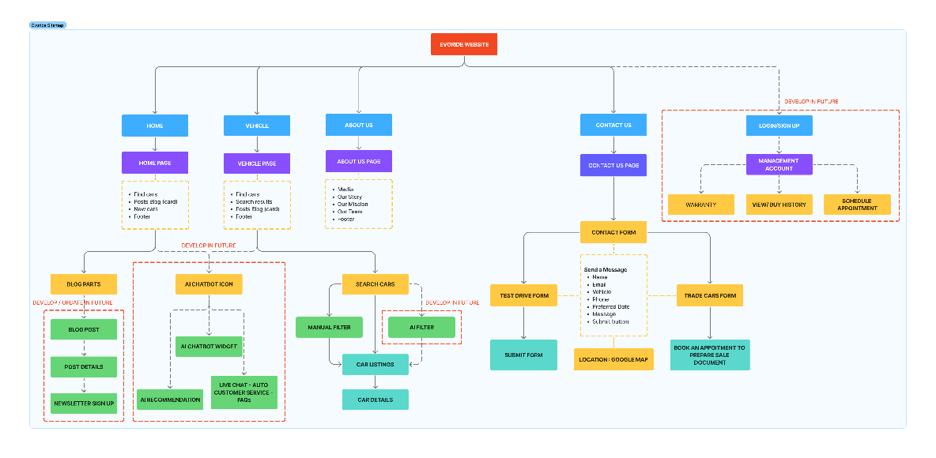  - Concept – Figma file:  Link file: https://www.figma.com/design/TqG4vt9RHHg5zwC6tXwraD/Assessment-2---Identify-and-Resolve-Client-ICT-Problems?t=qIzi7jlgs1joJDke-0  - Logo: revise the logo for better visibility and scalability. (Attached file)  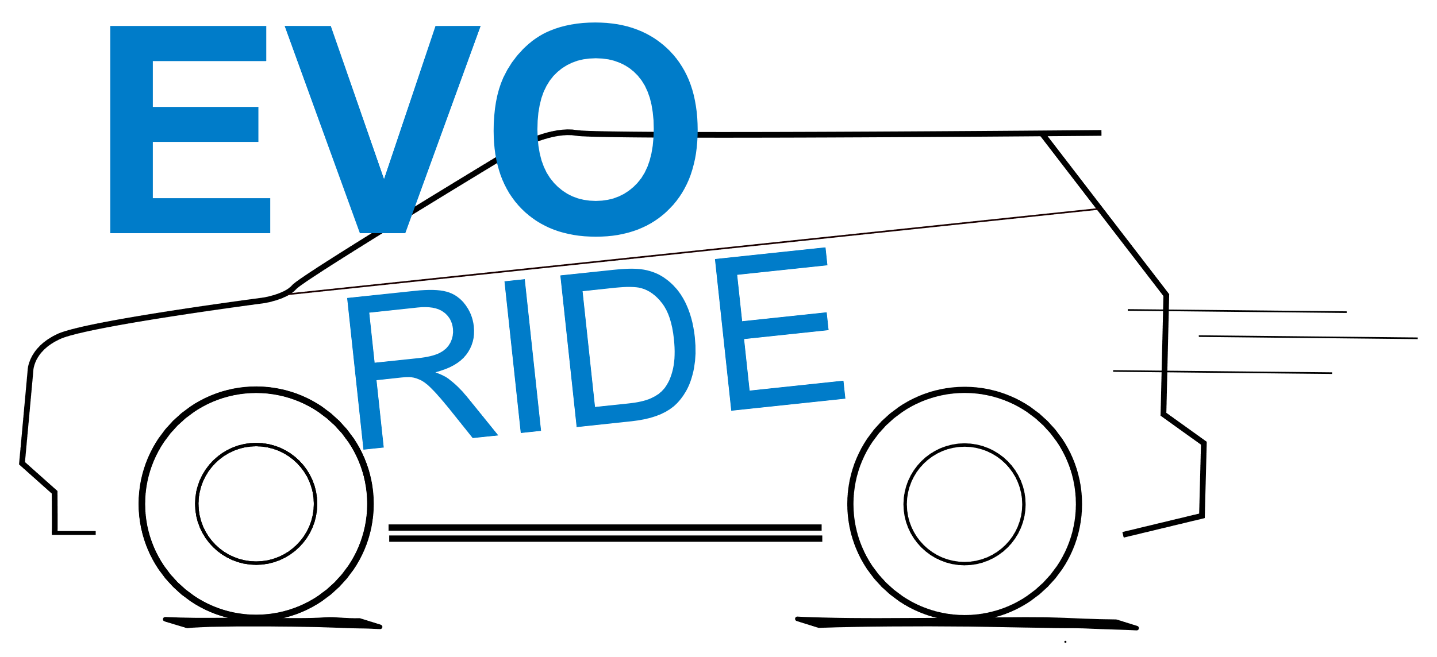 |  | Comment:
Question 4: | Have you stored and disposed of any used components used in the creation of your concepts? This can be things like pens, pencils, paper, etc. | Satisfactory response
 |  | Yes ☐ | No ☐
Answer:  Yes, I have properly stored all relevant sketches and notes for possible future reference. |  | Comment:
Part E | Confirmation & Feedback Observation
OBTAIN FEEDBACK AND APPROVAL FROM YOUR TEACHER BEFORE PROCEEDING.
The following checklist is to be completed by the facilitator
In this assessment task you will be performing the following activities: | Date 1  Satisfactory  Yes No |  | Date 2  Resubmission  if applicable  Satisfactory  Yes No |  | Date 3  Resubmission if applicable  Satisfactory  Yes No |  | Comment
- The learner has prepared a maintenance report according to the client’s organisational procedures. | ☐ | ☐ | ☐ | ☐ | ☐ | ☐
- The learner has distributed the maintenance report to client and seek and respond to client feedback as required | ☐ | ☐ | ☐ | ☐ | ☐ | ☐
- The learner has forwarded client feedback to required personnel for sign-off and record in problems database | ☐ | ☐ | ☐ | ☐ | ☐ | ☐
- The learner has resolved outstanding client requirements and escalated as required | ☐ | ☐ | ☐ | ☐ | ☐ | ☐
- The learner has sought and obtained feedback from the client’s organisational representative on assessment of impact of emerging technologies and practices and incorporate feedback into report | ☐ | ☐ | ☐ | ☐ | ☐ | ☐
- The learner has prepared a maintenance report according to the client’s organisational procedures. | ☐ | ☐ | ☐ | ☐ | ☐ | ☐
Part F | Final Maintenance Report
Question 1: |  | Your final designs should be now completed and included into your maintenance report. Insert your final designs below. | Satisfactory response
 |  |  | Yes ☐ | No ☐
Answer: |  |  | Comment:
Question 2: |  | List what your feedback was from the client and list how you responded to client feedback in your final designs | Satisfactory response
 |  |  | Yes ☐ | No ☐
Answer: |  |  | Comment:
Question 3: |  | List the client requirements and confirm that they have been met and signed off by showing a screenshot in your chosen database being resolved. | Satisfactory response
 |  |  | Yes ☐ | No ☐
Answer: |  |  | Comment:
Question 4: |  | Self-reflect on the effectiveness of your decision-making strategy, including what went well and what didn’t go well. | Satisfactory response
 |  |  | Yes ☐ | No ☐
Answer: |  |  | Comment:
Question 5: |  | Identify areas for self-development regarding the design process, critical thinking or researching technologies | Satisfactory response
 |  |  | Yes ☐ | No ☐
Answer: |  |  | Comment:
Question 6: |  | Document and develop a plan for future process evaluations regarding design workflows and client communications. | Satisfactory response
 |  |  | Yes ☐ | No ☐
Answer: |  |  | Comment:

Learner Acknowledgement and Cover Sheet
Academic Declaration:
By submitting this assessment task and signing the below, I acknowledge and agree that:
- This completed assessment task is my own work.
- I understand the serious nature of plagiarism and I am aware of the penalties that exist for breaching this.
- I have kept a copy of this assessment task.
- The assessor may provide a copy of this assessment task to another member of the Institute for validation and/or benchmarking purposes.
- For electronic submissions, by typing your name in the student signature field, you are accepting this declaration.
Learner name: Van Minh Le | Learner ID: 100693330
Submission Date: Insert date
Learner signature:

Section F – Feedback to Learner
Has the learner successfully completed this assessment task? Yes ☐ No ☐
Assessor feedback (as appropriate): Insert feedback
Resubmission allowed: Yes ☐ No ☐ Resubmission due date: Insert date
Assessor name: Insert name
Assessor signature:

